|  |  |  |  |  |
| --- | --- | --- | --- | --- |
| **Flinders University Self‐Assessment Workstation Checklist Ver 3.0 (6/12/2024)**  If you can tick all of the **green or white boxes** below then the work station meets the required Standards. | | | | |
| **Name:** Click or tap here to enter text. Supervisor: Click or tap here to enter text.  **College / Portfolio / Business Area:** Click or tap here to enter text.  **Location:** Click or tap here to enter text. | **Extension:** Click or tap here to enter text.  **Date checked:** Click or tap to enter a date. | | | |
| **Normal Work Activities:** Click or tap here to enter text.  Desktop PC  Mac / iMac  Laptop / Macbook  Keyboard Work  Manual Handling  Varying Multiple Tasks  Frequent movement | | | | |
| **Desk** | | **Y** | **N** | **NA** |
| Is the desk or bench space large enough to accommodate all work (*width and depth*)? | |  |  |  |
| Can the desk height be adjusted to suit the worker? *(i.e. height adjustable or adjustable feet*) | |  |  |  |
| When working at the desk (sitting / standing), is the desk at elbow height (i.e. not raised to desk)? | |  |  |  |
| Is there sufficient leg room beneath the desk or bench (*650mm wide x 450mm deep at least free*)? | |  |  |  |
| Is the desktop free of reflections / glare from its surface? | |  |  |  |
| Are frequently used items within normal reach (i.e. without overstretching)? | |  |  |  |
| If a keyboard tray is present, can it adjust freely? **Position:** Level  Lowered  Can’t Adjust (repair) | |  |  |  |
| If a corner desk is used, does it have a corner support or desk lozenge correctly installed? | |  |  |  |
| **Height adjustable / Sit Stand Desk** | | **Y** | **N** | **NA** |
| Can the workstation be adjusted to suit the worker at a sitting posture? | |  |  |  |
| Can the workstation be adjusted to suit the worker at a standing posture? | |  |  |  |
| Is the worker aware of the correct height for sitting and standing (i.e. marked / desk programmed out the levels)? | |  |  |  |
| If prolonged standing and cannot vary tasks, is a mat provided or alternative solution utilised? | |  |  |  |
| **Chair** | | **Y** | **N** | **NA** |
| Is the chair cushion / padding in good condition (i.e. not worn, dirty, lost its support)? | |  |  |  |
| If chair has arm rests, are they adjusted correctly to avoid impact on swivel action or seating position? | |  |  |  |
| Is the base of the chair stable (i.e. at least has a five-star base and has no ‘wobbles’)? | |  |  |  |
| Does the seat width and depth comfortably support the hips and legs? | |  |  |  |
| Does the chair offer adjustable lumbar support to support your lower back? | |  |  |  |
| Is the chair adjustable and working? | |  |  |  |
| Is the chair backrest angle adjustable and working? | |  |  |  |
| **Footrest** | | **Y** | **N** | **NA** |
| If a footrest is required, is one present, adjusted correctly and in working order? | |  |  |  |
| Are feet flat on floor or a footrest used to maintain thighs parallel to floor? | |  |  |  |
| **Laptop / Tablet / Computer case** | | **Y** | **N** | **NA** |
| If the laptop / tablet is used for prolonged periods, is an external keyboard, mouse, monitor and / or docking station used? | |  |  |  |
| If present, is the desktop computer case / docking station positioned to minimise impact on desk space? | |  |  |  |
| **Keyboard and Mouse** | | **Y** | **N** | **NA** |
| Is the keyboard used without propping up with the legs or thin keyboard used (i.e. 30mm or less high)? | |  |  |  |
| Is the keyboard wrist support provided?  Plastic  Gel  Other  None | |  |  |  |
| Is keyboard in good working condition (i.e. keys require normal pressure to use, clean)? | |  |  |  |
| Is the mouse comfortable to use, moves freely and fits in your hand? | |  |  |  |
| Is the mouse at the same level and as close as possible to the keyboard on the work surface? | |  |  |  |
| Are the keyboard and mouse within 10 – 15cms from desk edge and directly and symmetrically in front of the seated position? | |  |  |  |
| Are wrists in a neutral position when using the keyboard and mouse (i.e. wrist not bent)? | |  |  |  |
| **Display / VDU screens (Computer/ laptop/ tablet screens)** | | **Y** | **N** | **NA** |
| How many screens are present? Choose an item. **If more or other:** Click or tap here to enter text. | |  |  |  |
| What configuration are the screens used? Choose an item. | |  |  |  |
| Are the most used screen(s) positioned directly in front of the worker (minimise neck bending / twisting)? | |  |  |  |
| Is the screen at a comfortable reading distance (approximately an arm’s length away)? | |  |  |  |
| Is the image clear and stable (*i.e. not flickering, rolling, dull, too bright, screen size adequate*)? | |  |  |  |
| Is the operator looking at the top edge of the screen without bending the neck? | |  |  |  |
| Is screen height is adjustable? If not, is a monitor riser used? | |  |  |  |
| **Lighting (natural and artificial)** | | **Y** | **N** | **NA** |
| Is proper lighting available for the task (i.e. not too bright or too dull)? | |  |  |  |
| Workstation surfaces are free from glare (i.e. lighting is not reflecting brightly into eyes)? | |  |  |  |
| Are screens located so that users do not look directly toward or away from windows or strong light sources? | |  |  |  |
| **Noise** | | **Y** | **N** | **NA** |
| Does the noise level allow for concentration? | |  |  |  |
| Is noisy equipment located away from the immediate workstation area (i.e. separate room)? | |  |  |  |
| **Telephone** | | **Y** | **N** | **NA** |
| Is the telephone positioned to avoid reaching across the body and within normal reaching range? | |  |  |  |
| Is the correct posture used when answering the phone (i.e. not cradling phone in‐between shoulder and head; using headset; use speakerphone)? | |  |  |  |
| **Environment** | | **Y** | **N** | **NA** |
| Is the room / area at a comfortable temperature (*i.e. air conditioning works properly*)? | |  |  |  |
| Is the work environment clean and tidy (i.e. no dust, leaks in roofs, strong odour issues)? | |  |  |  |
| **General** | | **Y** | **N** | **NA** |
| Is current posture preventing neck twist or strain? | |  |  |  |
| If a document holder or adjustable surface is required, is it present, positioned and adjusted correctly? | |  |  |  |
| Is varying of tasks, where possible, and / or breaks used to move away from the workstation occasionally? | |  |  |  |
| Is there enough space to perform regular job tasks? | |  |  |  |
| Are cables secured and do not present a trip or entanglement hazard? | |  |  |  |
| **Details and Other Notes (any issues noted should be discussed with your supervisor)** | | | | |
| Click or tap here to enter text. | | | | |

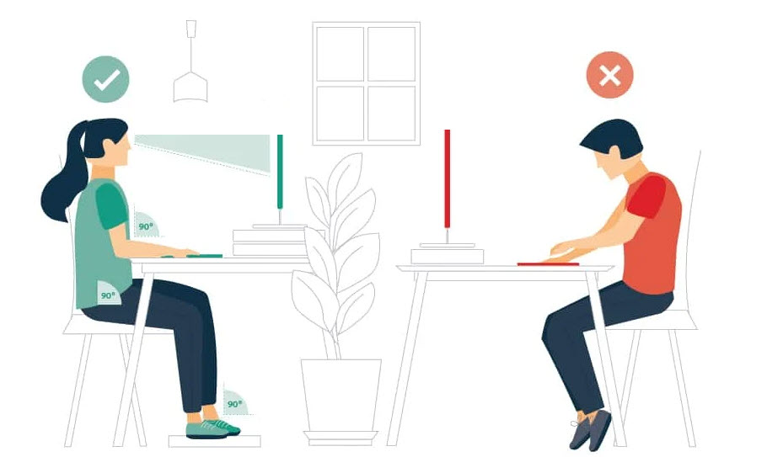

Source: [https://hw.qld.gov.au/](https://hw.qld.gov.au/blog/how-to-set-up-your-home-workstation-ergonomically/)

|  |  |
| --- | --- |
| Source: [https://www.worksafe.qld.gov.au/](https://www.worksafe.qld.gov.au/safety-and-prevention/hazards/hazardous-manual-tasks/working-with-computers/setting-up-your-workstation) |  |